Recap Hume and design arguments so far- Quiz/Test
- What were the 3 characters in Hume’s book (3)

- What was Hume’s book called (1)

- Hume can be called an E_ _ _ _ _ _ _ _ _ (1)

- State (in bullet form) the 5 criticisms Hume made against the design argument (5)

- Complete Hume’s quote- “Nature is ______ in _________ and claw” (1)

- Explain the example connected to Mexicans (2)

- Explain the example with a goldfish (2)

- What was the only way to ‘know’ things for certain according to Hume? (1)

- Give an example of design qua regularity and design qua regulation (2)

- What did Plato call the being that created the world? (1)

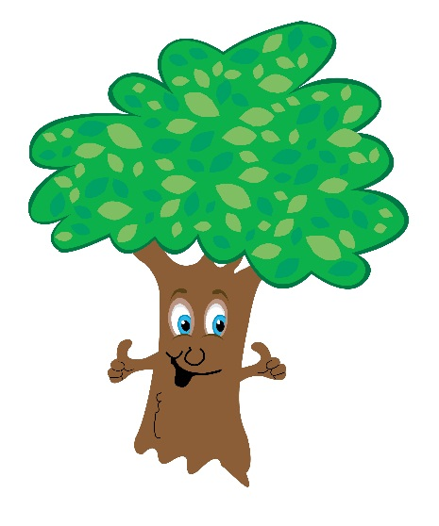
Total /40
14. Explain Paley’s watch analogy (10)
13. State the four causes from Aristotle and what they are for this pencil (8)
- The

- The

- The

- The

12. What has this tree got to do with Aquinas’s design argument (2)
11. Explain what this point is and what it is called (1)

