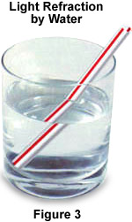
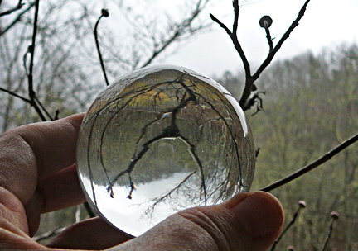

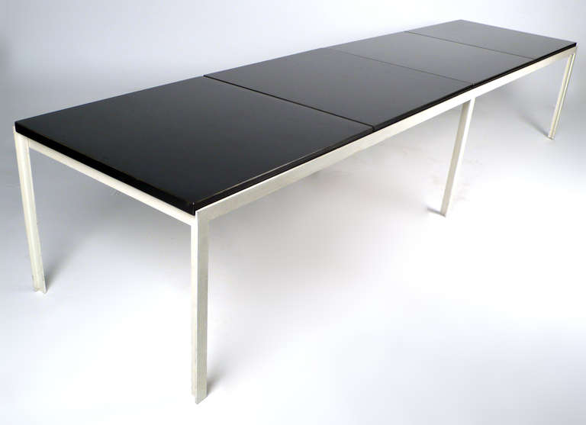
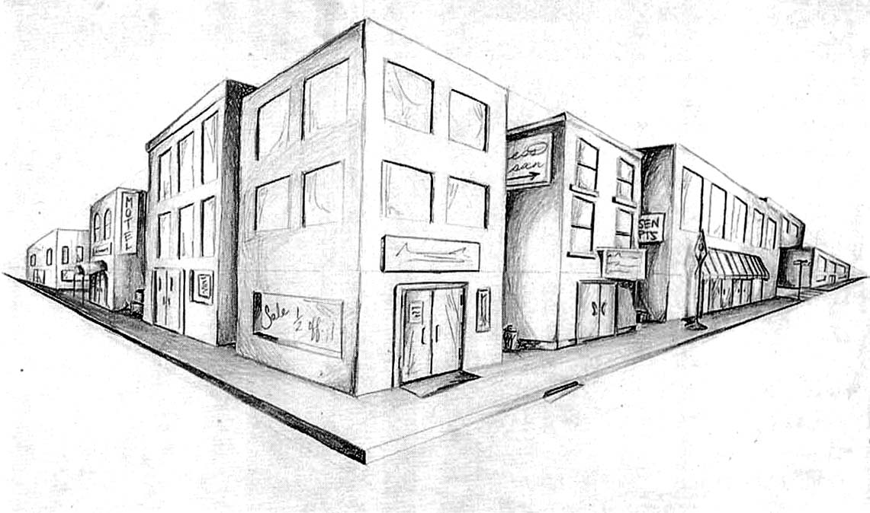

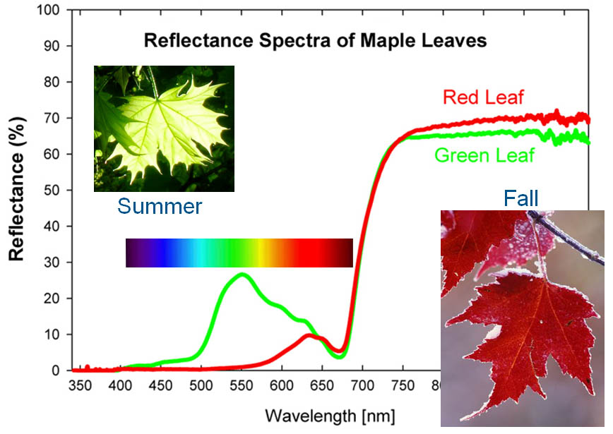
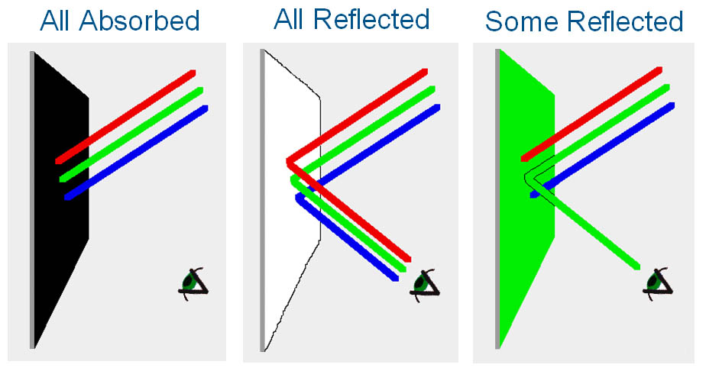

The colour of an object is determined by which wavelengths of light are reflected from the object. If no light at all is reflected, the object will look black. If all light is reflected, the object will look white. If only green wavelengths of light are reflected, the object will look green.
Image Credit: Irene Antonenko

A great example to explain this is the leaf spectrum. All vegetation reflects very strongly at infrared wavelengths (greater than 700 nanometers). If our eyes could see infrared, all trees, leaves, etc. would look infrared to us. But our eyes don't see those wavelengths, so the next strongest reflected wavelengths in the range we do see (about 400 to 700 nm) produce the leaf's colour. Chlorophyll, which converts sunlight to energy in plants, reflects most strongly at green wavelengths. This is why most plants look green. But, in deciduous trees, such as maples, the leaves stop producing chlorophyll when the weather cools. As the amount of chlorophyll drops, the strong chlorophyll reflectance in green disappears. This allows other compounds, which reflect more strongly at red or yellow wavelengths (but not as strongly as the chlorophyll does in green), to be revealed.
