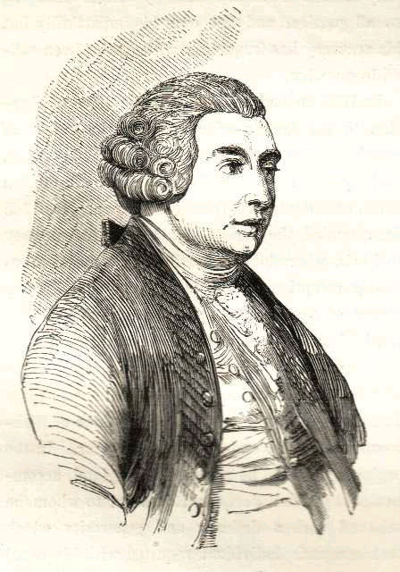

Extra notes on Hume:

5.

2.

4.

3.

1.

**Philo’s criticisms of Cleanthes’s Design Argument are................**

**CLEANTHES** - believes in Natural Theology, argues a posteriori to God & the design argument  
**PHILO** - is their critic and who puts forward Hume's own views.   
 **DEMEA** - puts forward arguments starting from a faith position and who is not directly relevant to the design argument.

David Hume’s (1711-1776) Criticisms of the Design arguments

In his book *Dialogues Concerning Natural Religion* Hume has 3 main characters that discuss arguments for and against the existence of God. Below you should summarise Philo’s criticisms of the design argument.