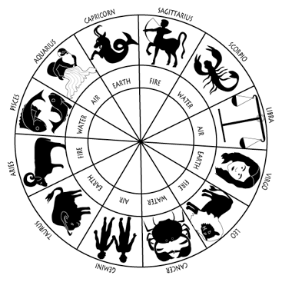
Read the stars with your Fallacy star signs!

 | You are going to win the lottery on Saturday. But be careful. Members of your family will be like vultures wanting to borrow money. If you give them £10, you will end up lending all of your winnings out and will be poor. Your lucky day is Tuesday. | Name of fallacy:  Explanation of fallacy:
 | Wow! You are going to have a great month! You will skip school and meet the love of your life. Remember it cannot be wrong to skip school everyone else does it! Look out for a man wearing a pink hat. | Name of fallacy:  Explanation of fallacy:
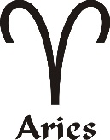 | You are a delicate soul. Everything bad always happens to you. This week you will either be knocked down by a car on Friday or catch a serious illness. Remember it will be one or the other. Wear a pink hat for luck all week. | Name of fallacy:  Explanation of fallacy:
 | You are going to clash with a fiery teacher this week. You are going to argue about the price of a festival ticket. The teacher thinks that the ticket is cheap, but you think it is too expensive. But what does the teacher know? He is stupid anyway! Luck lives at number 16. | Name of fallacy:  Explanation of fallacy:
 | It is common knowledge that Lord Archibald Shuttleworth had vibrant red hair. Therefore you must not believe anything he says! He warns you to beware of a stray rabid dog. But the stars say you should take it home. | Name of fallacy:  Explanation of fallacy:
 | You are going to get a job at a café this week. But you will have an argument with a fellow caterer. He wants to put less butter on the bread when making sandwiches. He says it will make the butter last longer. Why does he want to starve all of those poor people? It just doesn’t make sense to you! Ignore him. Wednesday is your lucky day. | Name of fallacy:  Explanation of fallacy:
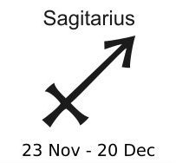 | As a Sagittarian, you are either boring or a glamorous celebrity model. In your case the stars say you are not a glamorous celebrity model! Therefore you must be boring. You don’t have a lucky colour. | Name of fallacy:  Explanation of fallacy:
 | You are feeling rebellious this week and when you go out for a drive on Friday you will drive on the wrong side of the road! Crazy! You will either crash into a red Volvo or into a blue Mercedes. Watch out for a red door! | Name of fallacy:  Explanation of fallacy:
 | Oh dear you are having a bad week. A rabid dog bites you and a man with a pink hat steals your homework. The teacher doesn’t believe you. You are best downloading an essay from the Internet. Don’t feel bad about it. Lots of students do it. Watch out for a car on the wrong side of the road on Friday. | Name of fallacy:  Explanation of fallacy:
 | Uh oh! Watch out for Virgos this month. They are out to get you! But as all Capricorns know Virgos are manipulative and evil. When you get in to an argument with a Virgo, just take no notice…remember how stupid Virgos are! You’ll receive bad news on the 5th. | Name of fallacy:  Explanation of fallacy:
 | On Monday you will be stung by a bee. So you will have to go to hospital. Consequently you will miss school. As a result you will fail your Thinking and Reasoning Skills exam. Consequently you will never get a job and never get married. You will die lonely and miserable all because of a bee! | Name of fallacy:  Explanation of fallacy:
 | On Wednesday your mum will tell you brother to tidy up his bedroom. It drives him mad. As you say why does your mum want you both to waste your lives doing nothing but housework? She just wants you both to be house slaves. On Thursday your house burns down. Look out for a rabid dog. | Name of fallacy:  Explanation of fallacy:

