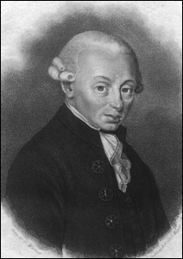
Coincidence or Design?

Immanuel Kant (1724-1804) questions how we can even be sure that order exists in the world. He rejects design arguments, saying that humans naturally categorise and order our own experiences. We could therefore be projecting order onto the world when, in truth, it is not there. The world might well be in chaos and we would not necessarily know, due to the fact that we cannot see the bigger picture, only our own perspective from our limited minds. Kant argued that the existence of God can only be proven using the existence of our inner moral ‘law’ as the starting point..

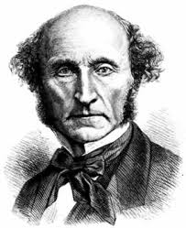
Evil God or no God?
John Stuart Mill (1806-1873), known for his utilitarian ideas, argued that evil alone is enough to prove that either God does not exist or that if he does, he is not all-loving. The pain and suffering that humanity is put through on a daily basis must force us to question the existence of the God of classical theism. Mill argues that nature is far crueller than the human mind. By implication, the “evidence” of design in nature points to a cruel designer, or else no designer at all. We will see more about this when we discuss the evidential problem of evil.

