Memory Method 1
Intensity -How intense is the pleasure or pain?
Duration -How long does the pleasure or pain last?
Certainty -What is the probability that the pleasure or pain will occur?
Propinquity (remoteness)- How far off in the future is the pleasure or pain?
Fecundity (richness) -What is the probability that the pleasure will lead to other pleasures?
Purity -What is the probability that the pain will lead to other pains?
Extent -How many persons are affected by the pleasure/pain?
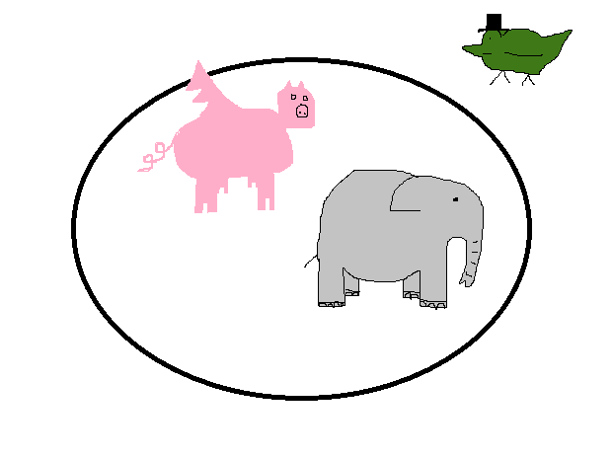
In Duck’s Circus Pigs Fly Past Elephants

Memory Method 2
Purity -What is the probability that the pain will lead to other pains?
Richness (propinquity)- How far off in the future is the pleasure or pain?
Richness (fecundity) -What is the probability that the pleasure will lead to other pleasures?
Intensity -How intense is the pleasure or pain?
Certainty -What is the probability that the pleasure or pain will occur?
Extent -How many persons are affected by the pleasure/pain?
Duration -How long does the pleasure or pain last?

